RE: Delayed Reception Start Date 5th September 2023

Dear parents/carers

As you are already aware our Academy was contacted by the Department for Education (DFE) following a structural survey carried out last month. Unfortunately, they informed us that Reinforced Aerated Autoclave Concrete (RAAC) has been detected in the roof in one of our Academy buildings. The DFE has concerns about the safety of the RAAC panels used to construct the building, in particular the roof.  This has resulted in a slightly delayed start to the new academic year.

We are now in a position to safely open large parts of the Academy, as such years 1-6 will start on Thursday 7th September. In previous years Reception pupils have been inducted into the Academy through a staggered start, at a slightly later date to the rest of the pupils. We intend to follow a very similar model this year; Reception pupils new to the academy will start on Monday 11th September at 9am and pupils who previously attended our nursery will start on Monday 11th September at 12.30pm.

We appreciate this is short notice, we have worked as quickly and safely as possible to welcome all pupils back to Ravens.

If you have any questions please do not hesitate to contact us.

Yours sincerely,

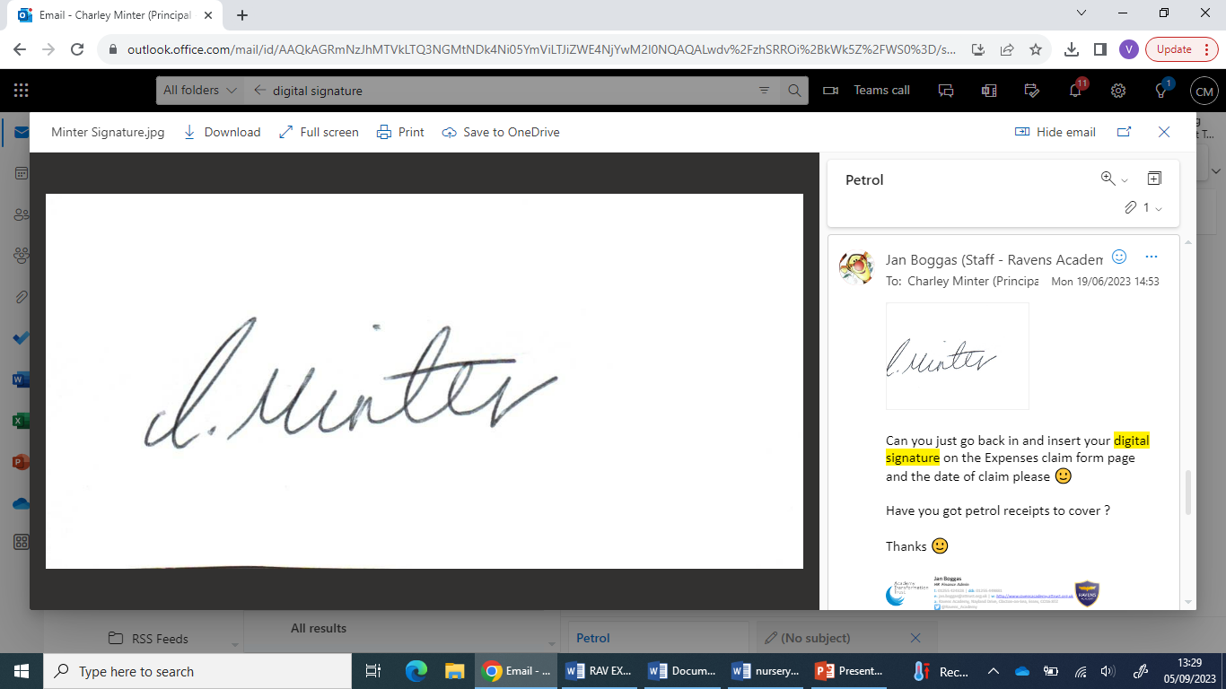

Miss C Minter

Principal