**Maths**

**Multiplication Practise** – Times tables check

<https://www.timestables.co.uk/multiplication-tables-check/>

Login to TTRS – Times table Practise

<https://ttrockstars.com/>

Hit the button – Number bonds, Doubles, Halves, Times Tables and Division Facts

<https://www.topmarks.co.uk/maths-games/hit-the-button>

**BBC Bitesize -Telling the time** – Watch the video, go through examples, activity 1 and complete the quiz.

<https://www.bbc.co.uk/bitesize/topics/zhk82hv/articles/zsvbp4j>

Practise:

<https://mathsframe.co.uk/en/resources/resource/116/telling-the-time>

**Crack the code:**

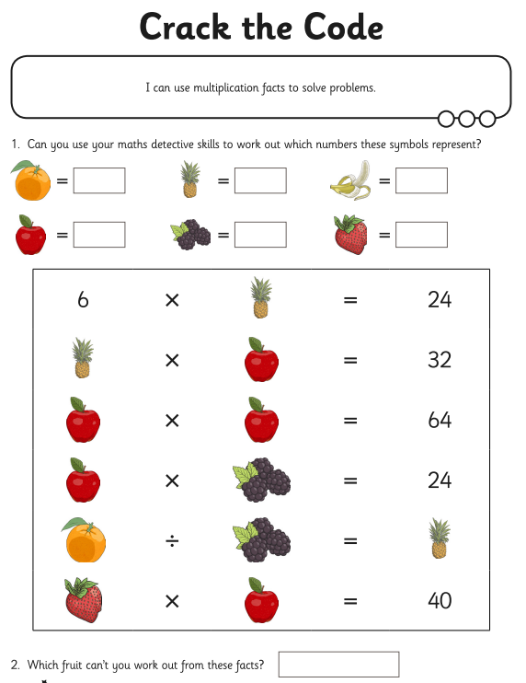

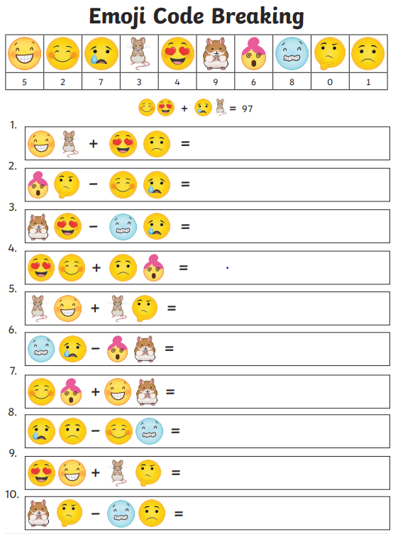

**English**

**Links to Year 5 Grammar Skills**

Conjunctions:

<https://uk.ixl.com/english/year-5/use-coordinating-conjunctions>

<https://uk.ixl.com/english/year-5/use-subordinating-conjunctions>

Nouns:

<https://uk.ixl.com/english/year-5/which-word-is-a-noun>

<https://uk.ixl.com/english/year-5/identify-nouns>

**Word puzzles**

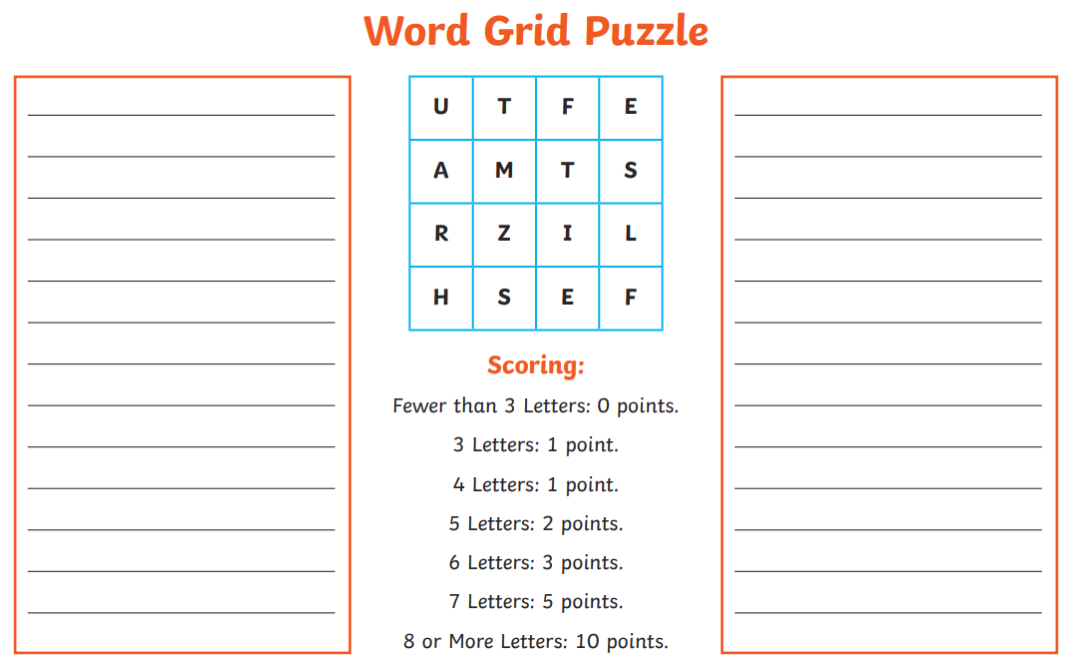

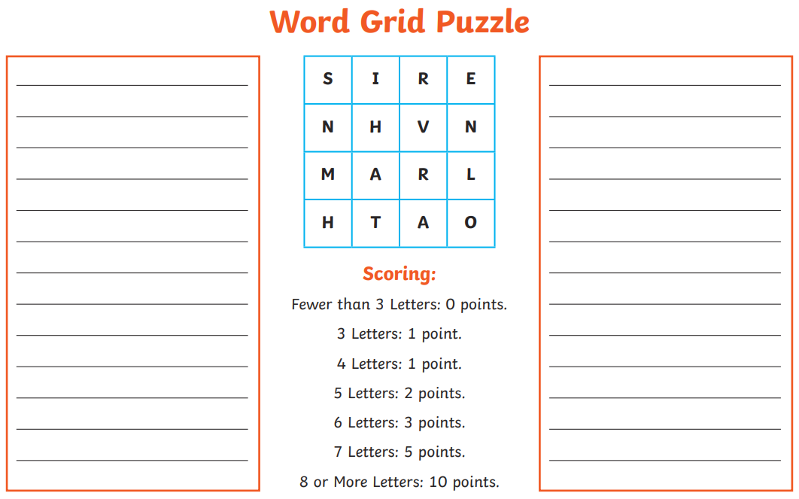

**Writing task:**

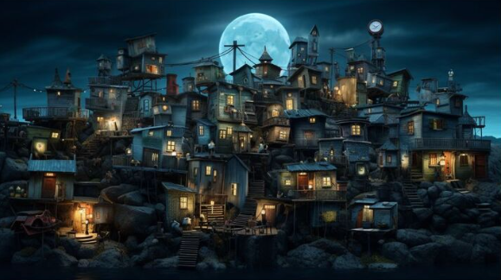

1. **Ask questions and make predictions about this picture.**

## Sentence starters - Use these sentence starters below to write your own sentence or paragraph.

Perched on a rocky shore was...

When the moon rose in the sky, the strange town...

People didn't understand about...

(Use the word bank below to help you…)

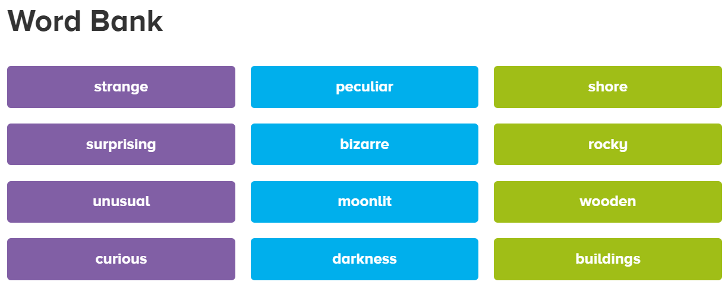

1. **Read the story starter** and continue the story using words from the word bank…(What happens next? You are now the author…)

**Story Starter for Strange Town:**

It was an ordinary night but this was no ordinary town. This was Strange Town.

During the day, everything was quiet. It came alive at night.

Now darkness was beginning to fall. Soon people would gradually begin to emerge from their houses. But…were they people at all? They certainly didn’t look like people. They were like their houses, all sorts of irregular, odd, shapes and sizes.

Passers-by always ‘tut-tutted’ as they passed Strange Town, not understanding its ways or its inhabitants. One thing could be said of the goings-on in Strange Town, however, there was never a dull moment…

1. **Question time**
2. What makes this town so strange?
3. Do you think the people of Strange Town are like you or me?
4. If you met one of the people who live in Strange Town, what 5 questions would you ask them?
5. **Sentence challenge -** Try and make these sentences even more interesting.
6. The town looked strange.
7. The houses were unusual.
8. The people came out at night.
9. **Punctuation challenge -** Add the missing punctuation to these sentences.
10. the unusual houses were built on the rocky shore
11. tiny yellow lights shone brightly in the buildings
12. at night the strange people of the town came out

**Visual Literacy**

Imagine that you have just walked into your kitchen to find this.

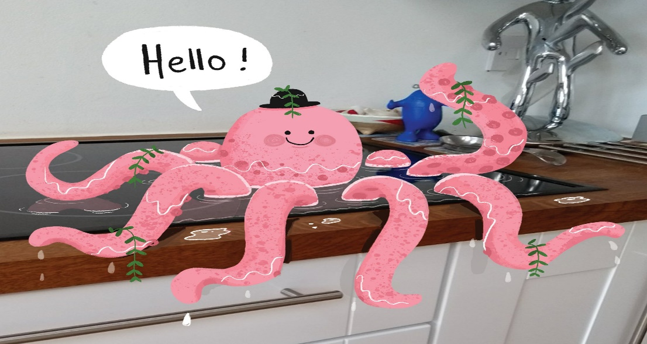Questions:

* How did the octopus get here?
* Why is it wearing a hat?
* Is it speaking your language? Do you understand what it’s saying?
* Where did the plants come from?

Extension - Choose:

* Role play the conversation you might have with the octopus.
* Role play the telephone call you might have with a friend or family member to tell them what you have found.
* You can only ask 3 questions to the octopus. What would you ask and why?
* You decide to let the octopus stay here, but the next morning you come into your kitchen to find it joined by another creature. What might it be?
* The telephone rings. It is the RSCPA and they are concerned: they have had reports from a neighbour that you are keeping sea life in your kitchen sink. What do you say?
* Try to persuade the octopus to leave. Then try to persuade it to stay. Which was easiest? Why?
* Write the story of how the octopus came to be here, and what happens next.

**Topic**

**Neil Armstrong research**

Watch the video and read through…

<https://www.bbc.co.uk/bitesize/topics/zjwvb82/articles/zhx4k2p>

Then complete this:

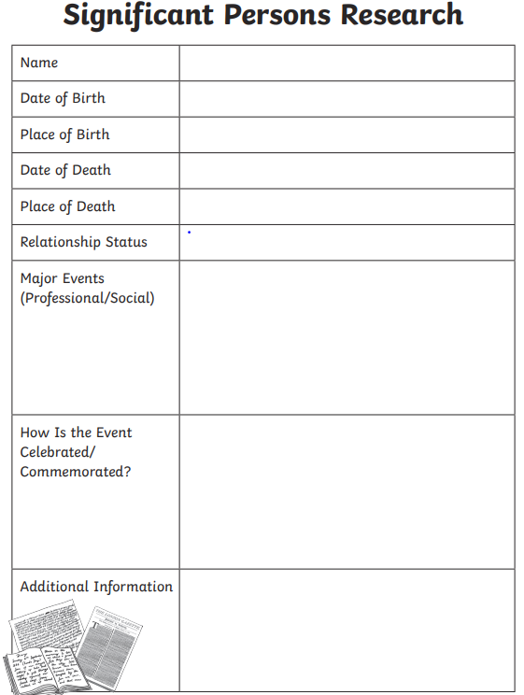

**Albert Einstein research**

Watch the video…

<https://www.youtube.com/watch?v=GjoYbsvUoO4>

Then complete this:



**Art**

Watch the youtube tutorials (pause regularly) and have a go at drawing Neil Armstrong and Albert Einstein…

**Youtube tutorial ‘How to draw Neil Armstrong’**

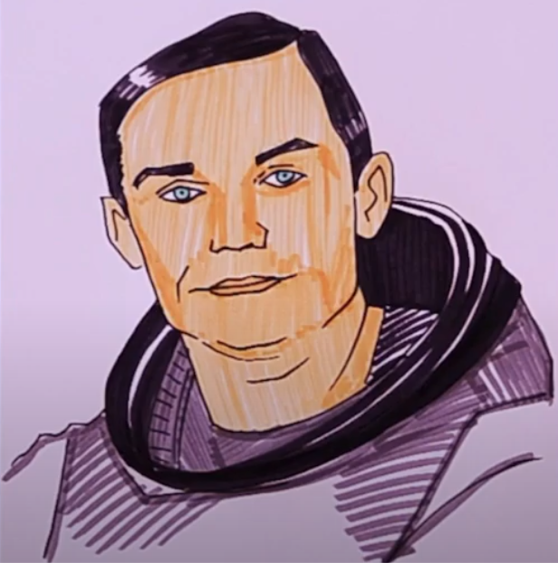

<https://www.google.com/search?q=neil+armstrong+art+ks2&sca_esv=562513523&rlz=1C1GCEV_enGB1033GB1033&sxsrf=AB5stBgXU7bVuXjEBRHGPkDvYfakVJzDUw%3A1693827562631&ei=6sH1ZICZJtKlhbIPgreFiAo&ved=0ahUKEwiAtrmx75CBAxXSUkEAHYJbAaEQ4dUDCBA&uact=5&oq=neil+armstrong+art+ks2&gs_lp=Egxnd3Mtd2l6LXNlcnAiFm5laWwgYXJtc3Ryb25nIGFydCBrczIyBhAAGBYYHjIIEAAYigUYhgMyCBAAGIoFGIYDMggQABiKBRiGAzIIEAAYigUYhgMyCBAAGIoFGIYDSMUPUMoDWM0OcAJ4AJABAJgBU6AB-AKqAQE1uAEDyAEA-AEBwgIIEAAYgAQYsAPCAggQLhiABBiwA8ICBxAAGB4YsAPCAgkQABgIGB4YsAPiAwQYASBBiAYBkAYK&sclient=gws-wiz-serp#fpstate=ive&vld=cid:684d334f,vid:EGPAoM-XDSs>

**Youtube tutorial ‘How to draw Albert Einstein cartoon’**

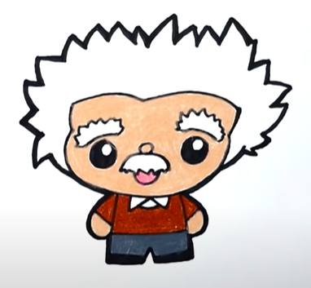

<https://www.google.com/search?q=how+to+draw+albert+einstein&sca_esv=562513523&rlz=1C1GCEV_enGB1033GB1033&sxsrf=AB5stBjKDI-Eb05x5hMLDEua-CJO3nc2qg%3A1693828177052&ei=UcT1ZJjsAtOxhbIP2timuAI&ved=0ahUKEwjY2LbW8ZCBAxXTWEEAHVqsCScQ4dUDCBA&uact=5&oq=how+to+draw+albert+einstein&gs_lp=Egxnd3Mtd2l6LXNlcnAiG2hvdyB0byBkcmF3IGFsYmVydCBlaW5zdGVpbjIKEAAYRxjWBBiwAzIKEAAYRxjWBBiwAzIKEAAYRxjWBBiwAzIKEAAYRxjWBBiwAzIKEAAYRxjWBBiwAzIKEAAYRxjWBBiwAzIKEAAYRxjWBBiwA0jFClD-BFjKCHABeAGQAQCYAU6gAb0BqgEBM7gBA8gBAPgBAcICBxAjGLACGCfCAgcQABgNGIAEwgIGEAAYHhgNwgIGEAAYBxge4gMEGAAgQYgGAZAGBw&sclient=gws-wiz-serp#kpvalbx=_VMT1ZIXrEbqlhbIPgPaNoAY_28>

**Which one did you find easier to draw and why?**

**Which one do you prefer and why?**

**Now try drawing your own portrait in a similar style to the Neil Armstrong picture…**

**Now try drawing your own portrait in a similar style to the Albert Einstein Cartoon…**

**Which one do you prefer and why?**